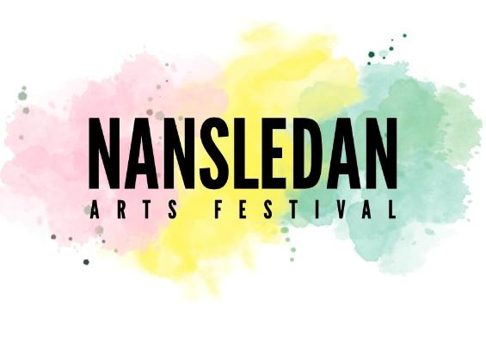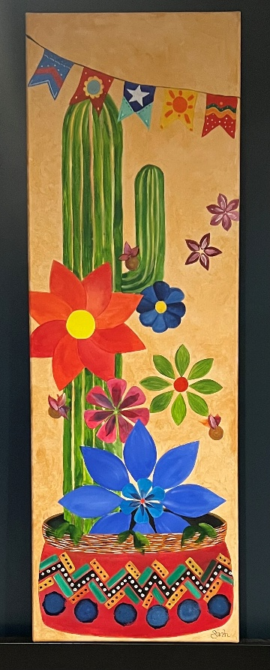
Our theme for 2026 is
Fiesta
ARTISTS’ FREQUENTLY ASKED QUESTIONS
The Arts Festival Art Trail is inclusive of all types of visual art and accepts work from beginners as well as established artists. (We reserve the right to refuse anything which might be deemed offensive).
Does my work have to follow the Fiesta theme? No.
Do I have to live in Nansledan to take part? You should live in the general Newquay area.
How many pieces will you accept? Generally, five. However we will accept groups of small items eg pottery. If you are unsure about a piece of work, or it is very large, please ask.
Is there a size limit? If in doubt about a large piece, please ask.
Can I sell my work? Yes. In pricing it please bear in mind that the Arts Festival will take a commission of 10%, which will go towards Nansledan Arts Festival 2027. If it is not for sale, please mark it NFS.
Where can I get an Application Form? By downloading from https://www.nansledanartsfestival.org.uk/art-trail or emailing nansledan.arts.festival@gmail.com
Where do I return the Application Form? By email to nansledan.arts.festival@gmail.com.
When do I need to return my Application form? As early as possible, but no later than 1st May 2026.
Do you accept crafts? Yes, but you may prefer to have one of our craft stalls, if you are selling.
We accept painting, sculpture, drawing, pottery, needlework, furniture etc, but it must be your own work.
How do I label my art? It should be labelled clearly, on the back or with a luggage label, with your name and contact details.
How will the Arts Festival label my work? The label will give your name and the title/subject of the work.
Can I supply business cards with my work? Yes.
Where will my work be displayed? In a shop window, or an empty shop or at Newquay Orchard’s Heart & Soul Café.
Alternatively, you may display it in a house window, but will need to advise the Festival of the details, on an Application Form, so you can be on the trail map.
Who will hang my work? Unless it is in a house or shop window, the committee will hang it. If you have an easel, it will be put on that. (Please name your easel).
I have easels/ hanging boards I could lend – would the Arts Festival like to borrow them? Yes, please.
When and where do I drop off my work? You will be notified, nearer the time, by email. You will be given a receipt/ your form will be receipted.
Do paintings need to be framed? Yes, unless you are under 18.
Do you have age restrictions? No, but if you are under 18 we need to know your age.
Do I need hanging fixings on framed paintings? Yes, ideally a hanging cord.
Can I exhibit anonymously? Yes, although we would prefer your work to be named.
Do I need a title for my work? That is up to you.
Will the exhibition be invigilated during opening hours? Yes.
Insurance? You are responsible for insuring your own work.
Can I help on the day, or in advance? Yes, please – do contact us.
How do I get my work back, afterwards? Place and times will be notified nearer the event. Please bring your receipt or identification.
Please note that Nansledan Arts Festival cannot store your work after Monday 22nd June, except by prior arrangement. The Festival reserves the right to dispose of any uncollected work as it sees fit, after that date.
Where can I get more information or ask another question? nansledan.arts.festival@gmail.com

