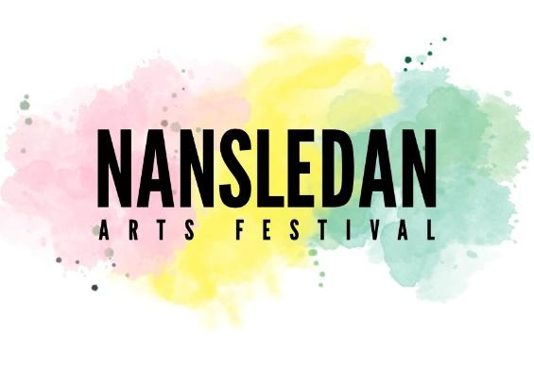
13th – 21st June 2026

Artwork Application Form
Please read the terms and conditions before completing. The application form is to be emailed to Nansledan.arts.festival@gmail.com to Joy Parker tel. 07375021899 or 01637 713028
Full Name ____________________________________ Age (if under 18) _____
Address ______________________________________________________________________________
_______________________________________________________________ Postcode ______________
Telephone________________ Email__________________________________________________
If possible, please attach images, ideally Jpeg, max size 3MB. No artwork to be delivered at this point.
Title of Exhibit (original artwork only) | Medium | Size | Sale Price | Office Use only (received/selected/ Collected)
 |  |  |  | Rc’d Collected
 |  |  |  | Rc’d Collected
 |  |  |  | Rc’d Collected
 |  |  |  | Rc’d Collected
 |  |  |  | Rc’d Collected
PLEASE BRING THIS RECEIPT OR ID WHEN COLLECTING YOUR WORK.
By submitting this form by email you are agreeing to the terms and conditions (see separate document)
Signed................................................. date.............................

